Mid-term Progress Report

1. Summary
- We have finalized the Blood Elf theme and completed the initial full set of unit pieces.
- All pieces have been imported into the Unity project following a consistent art pipeline.
- Movement rules for each unit class have been specified and aligned with the 8×8 board.
- Our progress remains in line with the targets set in the planning report.

2. Progress

2.1 Foundations
- We design Elf faction as our first aesthetic direction.
- Confirmed the board size as 8×8 (temp,it may change) validated camera framing, and ensured tile readability.
- Established the Unity project structure for further development.

2.2 Asset Pipeline
- Standardized import settings for all assets.
- Created a template prefab to streamline future unit integration.

2.3 Unit Roster
- Drafted the unit class list and defined movement rules at the design level:
- Kael’thas Sunstrider (King-like)
- Phoenix Matriarch (Queen-like)
- Runed Sunspire (Rook-like)
- Hawkstrider Cavalier (Knight-like)
- Spellweave Magister (Bishop-like)
- Sunwell Acolyte (Pawn-like)
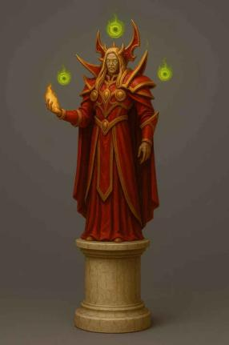  King | 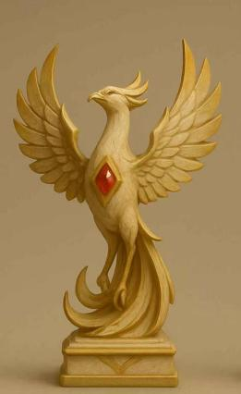  Queen | 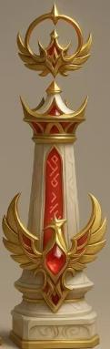  Rook | 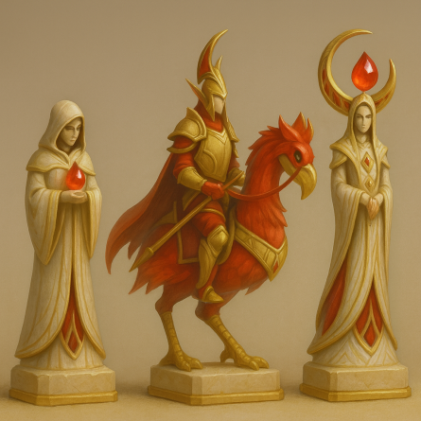  Pawn Knight Bishop
(We use gpt 5 & Keling ai + Photoshop for our art design、creation and modification)

2.4 Art and Prefab Creation
- Completed 3D models for all Blood Elf pieces and imported them into Unity.
- Created prefabs for each unit, including mesh, basic collider, and material assignment.
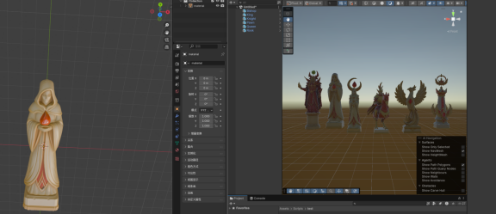
(We use Trellis & Hunyuan3d & Meshy + Blender for our model creation&modification)
- For initial testing, we temporarily adjusted the material to distinguish two sides. In the final game, different factions and materials will be used for clarity.(White, Black)

2.5 Movement Rules
- Finalized movement rule specifications for each unit class, ensuring logical and balanced gameplay.
-> temporarily follow chess rules.

2.6 Board and Readability
- Maintained the 8×8 board layout.
- Iterated tile sizing to match unit scale for optimal readability.
- Designed tile highlight states for selection and legal moves.
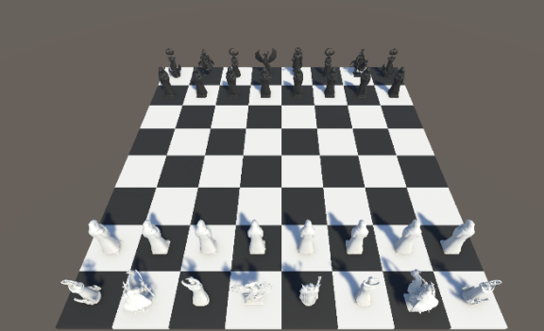
( A temp demo for display. )

3. Technical Notes
- Prefabs: Each unit is based on a prefab including MeshRenderer, MeshFilter, and Collider.
- Scales & Pivots: Unified model bounds for precise board alignment and future animation stability.
- Materials: Blood Elf palette (gold/crimson) with metallic and roughness settings optimized for readability under a top-down light rig.
(For demo , we use white and black to distinguish different sides.)

4. Deliverables Produced
- Art: Full Blood Elf unit set.
- Unity: Imported assets, prefabs for each piece and the initial scene with 8×8 board.
- Design Docs: Movement rule specifications per unit class.

5. Current Results & Display
- Our current 3D models and prefabs for the Blood Elf faction have been implemented.
- (2D concept art created by GPT-5 & Photoshop; 3D models produced using Tencent Hunyuan 3D, Trellis, MeshyAI, and Blender.)
- For testing, the camera setup is temporary and will be refined in future updates.
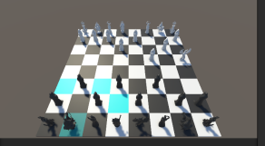  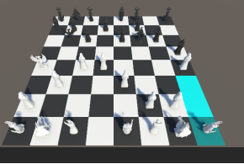 | 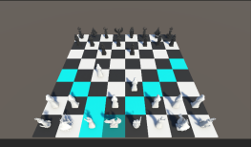  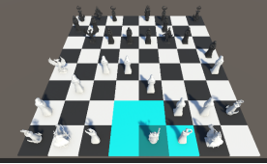
- We have implemented basic chess logic, allowing legal movements for all pieces.
- The project framework is established (note: Chess Set & Chess_pack are open-source Unity assets, but we have decided to design and build our own resources).
- The UI code is under design and currently being debugged.
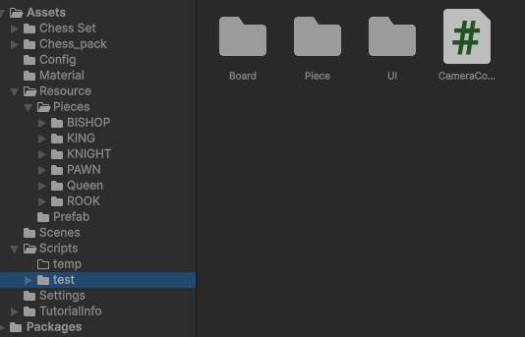

6. Next Steps
- We have already designed some skills and properties for the Blood Elf faction, with interfaces prepared for each piece.
- Next, we will add unique skills for the Blood Elf units.
- Animation concepts for skill usage are in development, though they may be challenging and could be reconsidered.
- The second faction is under design and currently being refined.

